6A^{th} Grade: Unit 4, Lesson 6
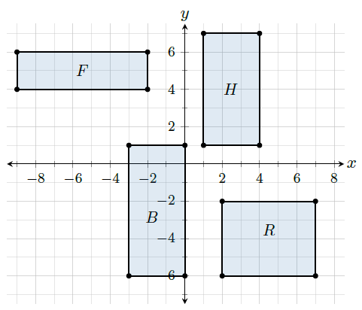
- Which rectangle on the coordinate plane has an are of 20 square units?

R

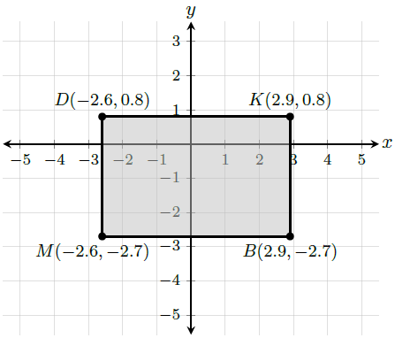
- What is the distance between point K and point B?

3.5 units

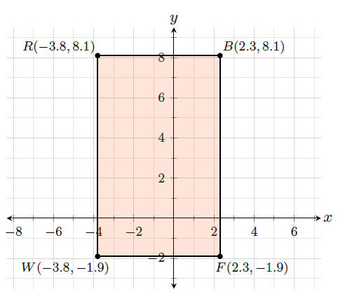
- What is the distance between R and W?

10 units

